Tag, You’re It
By David Rusbarsky
www.csh.rit.edu/~rhubarb/dainte
rhubarb@csh.rit.edu
The Idea

Massive is a program that was developed to allow thousands of entities to all interact with each other using artificial intelligence to guide their actions. Despite this program being fairly new, it has been used in elaborate commercials, music videos, and even in films, such as the Lord of The Rings trilogy. The steep price of this software makes it hard for researchers to obtain the software and experiment with it.
I decided to take it upon myself to develop a similar program that is aimed at allowing researchers to use for whatever they want to experiment with including genetic algorithms, neural networks, distributed systems, and just about any other field within artificial intelligence. I decided to utilize an existing graphics engine that also included the ability to create entities and an environment similar to what is provided in the end product of Massive. The software that I decided to use is called Muppets and was developed at The Rochester Institute of Technology for the purposes of education. Unlike Massive I wanted my program to be run in real-time, which would require the program to have a limited number of entities. This number would be significantly less than those used in Massive, so I decided to call my program Dainte (Misspelled so I can call it Distributed Artificial Intelligence Networked Team Entities).
To get a better understanding of Dainte, I should first explain Muppets in more detail. Muppets stands for Multi-User Programming Pedagogy for Enhancing Traditional Study. It is a collaborative virtual environment that allows people to write Java code and visually see the outcome through objects in a shared virtual world. These objects are called Muppets Objects, but for the purposes of this paper I will refer to them as entities. These entities can take the form of just about anything you can imagine. Models can be imported and these models can be manipulated within the code to make them seem to come to life. The Dainte players are an extension of these Muppets objects. For the Dainte players I have utilized two models (MD3 models); a Storm Trouper modeled after the ones seen in the movie Star Wars: A New Hope and an Alien model similar to the big black aliens found in the movie Alien. These entities are designed to be either controlled by a human or controlled through logic in code. I wanted both options for the Dainte players, so I decided to add in logic that would turn on or off the computer driven intelligence depending on if there was a human controlling that entity.
The world in which these entities appear in is also modifiable, however it is not done in a similar manner as to how the entities are modified. The Muppets world is basically the three-dimensional space in which the entities move around within. It also consists of the ground. This ground can be modified through the use of bitmaps that layout elevation levels. This ground can be covered with textures as well to give it a more realistic look. For the purposes of Dainte, I chose to use a simple flat ground with the default texture. This was done because any changes to this option would have resulted in some extra calculations by the Muppets program, which would slow down the system a little. The entities would be stressing the system enough as is, so I felt a flat ground would suffice.
When I talk about the Dainte world, I am referring to boundaries set upon the Dainte players (also referred to as the playing field), any obstacles that might be placed on the field, the Dainte team entities, and the Dainte players. The obstacles and Dainte team entities are created and brought into the Muppets world through the use of some methods built into each Muppets object. Once these objects are brought into the Muppets world, they begin to run their own code immediately. Besides bringing objects into the world, the Dainte class is responsible for initializing where each team’s starting/spawning location should be located, the number of teams that will be playing, the number of players each team should have, and for transferring messages from one Dainte team entity to another Dainte team entity. The messaging system will be explained in more detail later in the paper. The Dainte class is also the class that is called to start the entire process within Muppets.
The Dainte team entities are extensions of Muppets objects similar to the Dainte class, but have different responsibilities than those of the Dainte class. They are responsible for creating the Dainte players on that team. This is accomplished in the same manner as how the Dainte team entities were created. It is also responsible for knowing where its base is, how big the team is, and it will keep a list of all the players on the team. The Dainte team entity works as a middleman for the messaging system. If a message needs to go to a player that is on it’s team, then it will deliver the message to that players. If the message is supposed to go to a player on another team, then the Dainte team entity will send off the message to the Dainte class where it will be handled there.
The Dainte Player is where most of the logic is located. In this class, which is also an extension of a Muppets object, the entity will attempt to find a target and act accordingly when one is found. Here is a basic run through of the logic I implemented for both teams:

- Scan and store the findings in long range, medium range, and close range lists. Scanning consists of creating a list of all other Muppet objects within a certain range of the player that is scanning.
- If an enemy is in any of these ranges, choose the enemy that is closest and store it as the current target.
  - If the player who is scanning is on the attacking team (i.e. this player wants to tag the enemy players), then turn towards the target.
  - If the player who is scanning is on the running team (i.e. this player does not want to be tagged by enemy players), then turn away from the target.
- Each of the three ranges will result in choosing a different speed to move at.
  - At long range the speed is set to walk.
  - At medium range the speed is set to run.
  - At close range the walking movement is randomly chosen between side stepping to the left or running forward. Each has an equal chance of happening. This was done to help avoid collisions between two entities.
- If the target is within the short range sensor, it is considered a tag and the tag logic is executed:
  - If the scanning entity is on the attacking team, set your current target to null so a new target can be obtained.
  - If the scanning entity is on the running team, change teams over to the attacking team, and change colors to the same color as the attacking team.
- Check to see if the scanning entity is still on the field and correct the location if it is not.
This logic can be found in the processAI() method and the other methods that are called by processAI() in the DaintePlayer class. If a researcher wanted to change the logic or insert their own logic, the processAI() method is where they would do so.

Logic Diagram
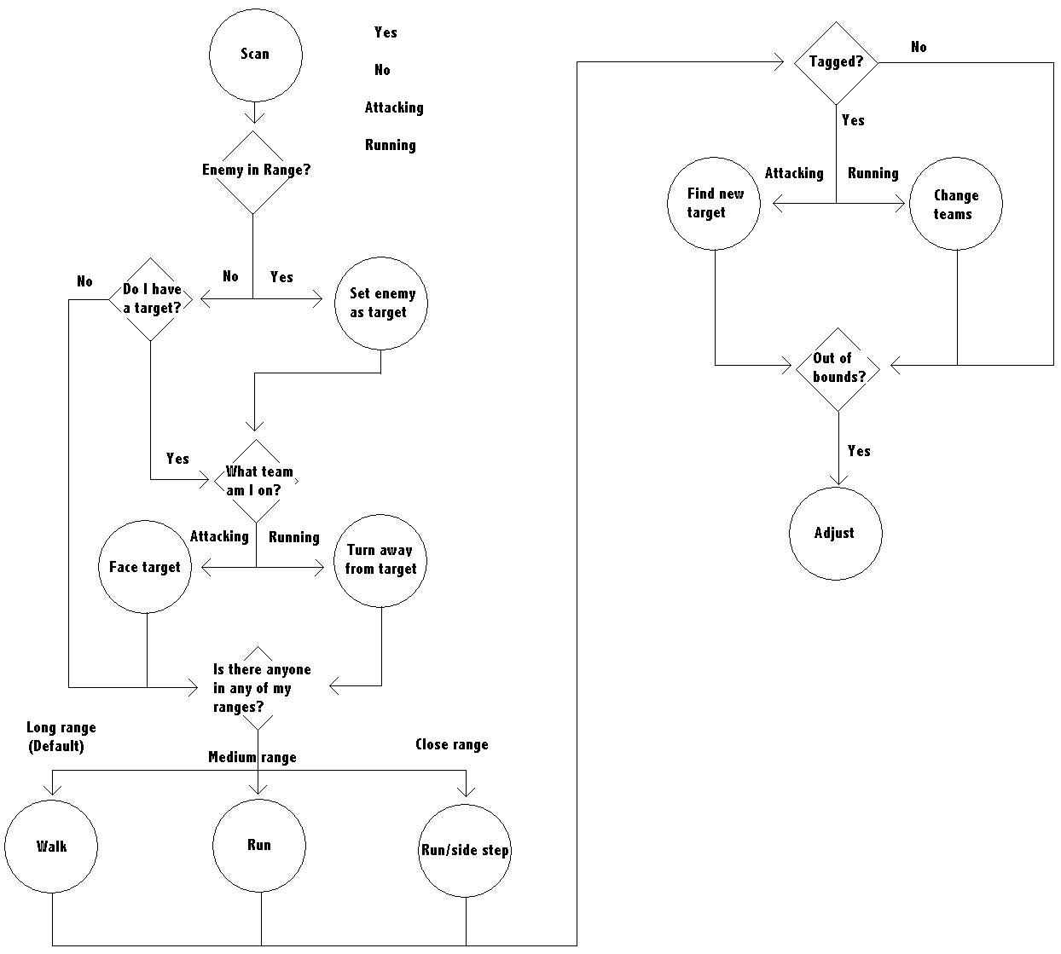

The statistics for each player are what gives the players their own personality. These statistics are stored in their own class called DaintePlayerStats. The stats class is responsible for holding all the information about the Dainte player that is associated with that class including (but not limited to) the name of the player, the model the player is using, the id of the player (the id is a number between 0 and the total number of players on a team minus 1. This helps the Dainte team entity to parse through the players), the player’s base location, the team the player is on, the current target, the values for what is considered to be in long, medium, and close range, and the list of what is in each of these ranges. I added several different traits in the stats class that were not used in this project, but I left them there as ideas for different stats that can be used in the future. Depending on what game is implemented, these stats might be useful.
Similar to the ideas in Massive, I tried to implement certain aspects such as the ability to hear someone that is close to you and act accordingly to avoid collisions and the ability know who is on your team and work with them to achieve a team goal. In order to test out my program, I chose to code in the rules to the game of vampire tag. Vampire tag is your basic game of tag except when someone from the team that is “it” tags someone from another team, that person now joins the team that is “it.” The code for this style of game is found under the handleTag() method in the Dainte player code. If a researcher wanted to modify the rules to the game or wanted to choose an entirely different game, this is where the new game would be coded in.
The first thing that was to be accomplished for the Dainte project was to get the entities to move, turn, and obey the rules of the world such as they must spawn at a certain spot and not to leave a specified area. This was important because it would be heavily utilized for the rest of the project. Once this was achieved the next step was to get the entities to obtain a target that was an entity on the other team. Depending on what team the entity was on dictated how they should act in respect to the target. In the case of vampire tag, if you were on the team that was it, you were to run after your target. If you were on the other team you would try to run away from your target. The target was set to the entity that was closest to you that was on the opposing team. The next step involved coding the rules to vampire tag into Dainte, which basically entailed determining what happened when someone tagged someone else. I wanted to make this portion of the code, as well as a few other portions, easy to change or override so that if someone wanted to change the rules to the game to create a different game or to change the actions of the entities it would be easy to do so.
Dainte has a hierarchy to help manage and organize the players. The Dainte world (Dainte.java) creates the team entities and any objects they might be put into the world such as obstacles or walls. For my implementation of vampire tag, I did not include any obstacles in the world. The objects that are put into the world would be placed into the world as a team or several teams and what you want the entities to do when they get close enough to one of these objects is handled in the logic for the entity. The team entities (DainteTeam.java) that are created by the Dainte world will create the actual players on the team. This is the time to assign the initial stats to each player and to give them each their own set of skills. The team entity will also remember where their team base is incase an entity needs to return there, such as in the case of a death where the player needs to respawn. The Dainte player (DaintePlayer.java) is where the logic for the player is coded for both (or all) teams. Each player has a set of statistics (DaintePlayerStats.java) that keeps track of all the information that is relevant to that particular player entity. This is where you would add in any traits that you might want your entities to have, such as an intelligence trait to make some entities intelligent while others are not as intelligent. Some of the more important traits that the stats hold include which team the entity is on, current target, and their rotation with respect to the world around them. These four files, combined with some pre-existing programs already written in/for Muppets, make up the entirety of Dainte.
Something that was not included in Massive was the idea of a messaging system. Now that I have finished my version of the program, I can see that a messaging system is not critical or necessary, but I still included it incase some future research requires it. My messaging system utilized the hierarchy that was already in place. A player can write a message and put it in their mailbox to await delivery. The team entity will query its players to see if anyone has a message to send. If so, the team entity takes the message out of the player’s box, determines whom it is supposed to go to and either passes it down to the proper player if the player is on the same team, or passes it up to the Dainte world entity. The Dainte world entity then passes the message to the proper team who then passes it on to the proper player.

Message path within the same team
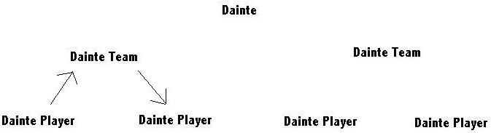

Message path between teams
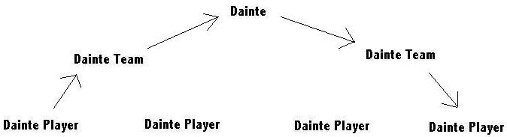

Problems Encountered

Despite my attempt to spend extra time on the planning stage of this project, I still ran into a significant number of problems. The first problem that needed to be addressed and would be addressed throughout the entire project is the ability for the players to act in real time and not bog down the Muppets system. If the system was bogged down with calculations then the players would look jittery and with enough bogging down, the players would not act at all like they were programmed to, basically becoming mindless players that would run (jitter) forward and maybe turn once in a while. The solution to this problem was to try to keep the code to a minimum while still achieving the goals set forth by the project. Another solution that was implemented in addition to keeping the code minimized was to just change the number of people that each team contained. The speed of your computer basically will dictate how many entities you can have on each team and still have it function properly.
The next problem I encountered was what to do with the players when they reached the boundary for the game field. I originally had them ignore their logic and turn gradually until they came back into the field. This sometimes resulted in a player going around in circles indefinitely. The next solution I tried was to essentially kill the player (invoke the dead() method and respawn that player at their base). This worked nicely except the entities were next to impossible to catch since a runner would just run out of bounds to avoid a tagger, respawn at his base, then continue to run away until he found the edge of the field again. My current solution is to have the player not allowed past the edge of the field and to have them turn to the left until they are no longer running into the edge of the board. This solution has its own faults that I plan to address in the near future. For the purposes of this class, however, the current solution will suffice. My idea for a possible solution is to add in another target object to the stats class. One target object would then be for the targeting of other players and the second target object would be for targeting walls and obstacles that you want to go around. A combination of these two targets would allow a player to track the other players and determine which general direction it should run in while still avoiding obstacles including the boundaries to the field.
A problem that I encountered with the targeting system was when there were two targets that were equally spaced away from a player. This would result in the player bouncing back and forth between the two targets rapidly. This could be solved if I was able to solve another problem involving the fluid movement of the players. The problem does not affect their ability to run away or chase a target and the player usually resolves the conflict within a second or two once the two targets move a little. Due to their ability to resolve the conflict on their own in a timely manner, I decided not to look further into this problem and left it alone.
I had originally planned to have an interrupt style of messaging in that if a player had a message he wanted delivered, he would tell his coach (the Dainte team entity). This coach would then pick up the message and do whatever was proper for that message. I thought this method was impossible because of the way Muppets is set up. When a Muppets object gives birth to another object (i.e. one object brings another object into the Muppets world), the parent object knows who it’s children are, but the children don’t know who their parent is. This could have been solved by having a pointer to the parent in the Dainte stats class that was assigned when the Dainte team entity creates the players, but I did not think of this idea until a sat down to write this paper. Luckily (or unluckily depending on how you want to view it), I recently had my hard drive fail on me and I lost all the code I had done on the messaging system. Now when I rebuild that code I can do it even better. The original method I had implemented was a polling system where the team entities and the world entity all polled the entities beneath them to see if any messages were ready for pickup. This, as you could imagine, also bogged down the system. The solution I had to the polling system bogging down the program was to just not include the code for messaging since the entities were not sending anything at all. The entities that I created did not need communications to accomplish their goals. The new system of messaging will be implemented as soon as possible.
When I was coding up the rules for vampire tag, I wanted to change the models of those who had been tagged so that you could tell that they had been changed over to the other team. Muppets apparently does not let you change your model on the fly without having to create an entirely new entity. This could have been done. I have the ability to create an exact clone of a player and change some minor things before sending it into the Dainte world. I decided to keep the model and everything else about the player, but change the color and their team number. This would then allow the people viewing the game to know who had been tagged and who had been on the original tagging team. It also cut down on the amount of code to be executed when a player was tagged and they had to switch teams.
A problem that still gets some tweaking and will probably always need some adjustment are the values for the stats. How far should the long range sensor be? How long should the medium or close ranged sensors be? How fast should a player be able to turn? These questions could be asked about all the stats that weren’t used (such as stamina) and all the future stats that will be added to the project. It takes time to try to balance out all the stats to try to obtain a “good” outcome. As I mentioned earlier in this paper, this project allows for all sorts of fields of artificial intelligence to find their way into the project. A good way of determining what values should be assigned to the players might be to use a genetic algorithm or a neural network to have the computer change the values for you.

Results

The results of this program were basically what I expected to see. The attacking team would eventually be able to corner and trap some of the runners, almost always near the edge of the field because of the way the rules state that if you hit a wall, then you must turn left and escaping your target at this point in time is secondary to staying on the field. Once tagged and converted, the attacking team would have more members so catching the remaining runners would become easier and easier.
One of the behaviors that arose that surprised me was the pairing up of two entities on the same team. This would allow both of them to run side by side where their close proximity would bring them into a state that runs around quicker than the other entities who would walk around by themselves. Another behavior that seemed to appear was the eventual formation of a flock or grouping of the attacker group. This was probably brought on by limited supply of targets for them to choose from, so it was only logical for many of the attackers to choose the same target. This would then result in something resembling a flock. As mentioned earlier in the problems section, one of the resulting effects of the targeting system would sometimes make an entity bounce back and forth between two targets that were equidistant from the target. This is apparently a common problem in reactive systems similar to the targeting system that I implemented. Since this is a rare occurrence within Dainte, I did nothing to try to rectify the problem. The problem is an interesting one nonetheless and the solution I was prepared to implement if the problem turned out to be bigger than I thought it was included physically moving the entity closer to one of the two targets just enough to avoid the bouncing effect. One last observation that I had when I watched the entities play their game was what I called the revelation effect. This usually occurred near the end of a game where there was only two or three entities left on the running team. At what seems to be a random point in time, multiple entities on the attacking team all of a sudden appoint one of the runners as a target even though it seems as if the runner is outside of the long range sensors of some of the attackers. This makes no sense to me because there are no messages being passes that contain this information and there are no gestures or any other form of communication that would share the location of a target with any other entity. One possible reason for this to occur might be that multiple attacking entities are chasing down a single running entity. Once one attacker tags the running entity, that one attacker gets his target reset to null so it can obtain a new target. The other entities that were chasing the same target might end up keeping that target even though it is on the same team now. This might help explain the part of the anomaly where the entities will seemingly realize which direction they want to travel in, but I am still confused as to how the new target could be obtained when it seems to be outside the sensory ranges of the attacking entity.

Future Work

There is a lot of potential that I see here for continuing the project in so many directions. A genetic algorithm or neural network could be created to adjust the sensor ranges and other statistics to possibly create a better entity. The graphics could be improved to actually show the entities tagging each other. Obstacles could be put in the field to help give the runners a place to hide. I believe that the Dainte project is a good start to recreating a similar environment as to the one developed for the Massive software. Where as I don’t believe we will be seeing Dainte in any movies, music videos, or commercials, I do think that it could be used to help other people perform research in several different aspects of artificial intelligence relatively easily while getting visual feedback through the three dimensional world provided by Muppets.

